“Once Only” Drop Capability in the
Linux Routing Software

Submitted to the
Department of Computer Science
College of Computing Sciences
New Jersey Institute of Technology

in Partial Fulfillment of
the Requirements for the Degree of
Master of Science
By
Viraj Ajgaonkar

APPROVALS

Proposal Number:_________________________________

Approved by: ____________________________________
( Dr. Teunis J. Ott)

Date Submitted: __________________________________

Abstract
This Project adds a capability to the existing Linux Routing Software. The new capability is to give a number n and a specific pattern to the software and make the software drop the packet if the packet contains the pattern and is within the first n packets of the flow having the pattern. Here n is known as limit of the flow. Subsequent packets of that flow containing the same pattern need not be dropped.
For e.g.:- Let the pattern be “yikes” and the limit be set to 3. Then for each TCP/IP flow the first 3 packets containing “yikes” are dropped. The subsequent packets containing “yikes” are not dropped.
For testing and verification this project also makes use of some network sniffer softwares like Tcpdump and Ethreal.
- Introduction
  - Problem Definition
My project aims at building customizable Linux Routing software. Linux is open source i.e. it allows user to modify the operating system according to their requirement. In this project we will use this feature to access some ‘Network’ variables in the Linux Routing software of the kernel in our Router. Also we will add some user defined functions which will process the routing mechanism in a desired way and will study the effect of these modifications on the flow of data between different systems that passes through this router.
My project customizes the existing Linux kernel routing software to give the user the ability to drop a particular packet based on the contents of that packet and also gives the user complete control on the number of packet of any flow having that content to be dropped.
Source
Destination
Router
Internet
Internet
Considering the above figure, Source and Destination are two hosts separated by either one or more networks. The Router is a host on one of the networks between Source and Destination also Router forwards the packets from the Source to Destination and vice-versa. My software which is loaded at the Router adds a new capability to it. This capability is to drop the first n packets of the flow from Source to Destination which contains a particular string in the TCP Data.
e.g.:- Considering the flow from Source to Destination. If the packet of this flow does not have the string “yikes” then the packet is forwarded to Destination. The first 10 packets of this flow having the string “yikes” in the data part are dropped and all subsequent packets of the flow containing “yikes” are let through. Thus we can do packet filtering on the basis of the content and also control the number of filtered packets.
  - Previous Work
This project study is based on the information provided by the Linux 2.4.xx kernel code, documentation files and different RFCs. The previous work in the field of customizable Linux Routing software targeted routers that were capable of dropping all packets from a set of source hosts or going to a set of destination hosts or passing through a particular interface. However not much work has been done for routers that drop packets based on their data contents and also routers where users can control the numbers of packets to be dropped. This project gives the user ability to drop packets in a router based on the data content and to decide the number of packets to be dropped.
  - Glossary
IP: Internet Protocol
TCP: Transmission Control Protocol
UDP: User Datagram Protocol
Host: A computer which may be working as a standalone machine or may be connected to some network.
Router: A host which has at least two active network interfaces and has the capability of forwarding IP datagrams.
Source: A host which initiates the TCP/IP connection.
Destination: A host that participates in the TCP/IP connection initiated by the Source.
Internet: The vast collection of interconnected networks that all use the TCP/IP protocols and that evolved from the ARPANET of the late 60’s.
DNS: Domain Name Server
GOME: GNU Network Object Module Environment
LILO: LInux LOader
MTU: Maximum Transfer Unit
NIST Net: National Institute of Standards and Technology (NIST) Network emulation tool
RTT: Round Trip Time
RPM: Red Hat Packet Manager
- Design
  - Approach
There are 2 possible approaches for implementation
- Kernel recompilation.
- Modules using Netfilter hooks.
Detail Description of the methods
- Kernel recompilation: In the kernel recompiling method we have to go through the Linux networking code located in the dir xxxxxxxx and find the exact function where we have to insert our code. Then we have to make the appropriate changes to that function to implement the required functionality. A good practice of doing it is to comment the original function and replace it with the new function having the same definition. Finally we have to recompile the modified Linux Kernel. Recompiling creates a new Kernel image incorporating the changes we made. Kernel recompilation keeps all the previous Kernel images unaltered. Then in order to see the effect of the changes we have to reboot and boot up using the newly created Kernel image.
- Modules using Netfilter hooks: In this approach initially we see the locations of all the available Netfilter hooks and decide as to which hook is the best possible location for inserting our functionality. Then we design and implement the functionality and save it in the form of a handler function which is coded in C. e.g. the handler function can be saved as router.c. Then we create a module in which we register the handler function and in this module we also bind the module to one of the available Netfilter hooks. E.g. we can save the module as viraj.c. Lastly we write a make file (makefile) that compiles the module (viraj.c). Now we compile the module by executing “make”. The compilation gives us a executable file (viraj.o). Now inorder to load the module and see the effects we need to install the module using the command “insmod viraj.o”. Finally inorder to stop the module and also its effect we have to uninstall the module which is done using the command “rmmod viraj”. The effects of the module are automatically written in the log which is located in the file /var/logs/messages. The process of installing and uninstalling the module can be compared logically to mounting and unmounting of an external drive. e.g. :- Firstly we mount the floppy drive using “mount /mnt/floppy”. Then when we have done the required operation of the floppy drive and finally we unmount the floppy drive using “umount /mnt/floppy”. Similarly we install the module using “insmod viraj.o”. The module binds itself to the proper hook and whenever the execution point reaches the hook, this module is executed and this module inturn calls the handler function (router.c). The handler function returns one of the standard return types and ends its execution. Finally when we want to stop the effect of the module we simply uninstall the module using “rmmod viraj”. For any subsequent executions of the kernel when the execution point reaches the hook it doesn’t find any module installed hence the execution will pass to the next line of the linux kernel code and the handler module is not called.
  - Deciding Factor
  - My project involves making changes to Linux routing software at ip layer and study the effect of these changes.
  - In recompilation approach for every change we have to recompile the entire kernel which takes a long time (approx 45 mins) also frequent recompiles makes the kernel fragile.
  - In netfilter hook option, we can see effects of the changes we made in a short time (2 secs) by just recompiling the module as compared to the lengthy recompilation of the entire kernel.
  - By using netfilter hooks the module written is portable as we can implement the same functionality on any Linux router by simply copying and loading the module. Whereas in kernel recompiling approach the benefit of the code is available only on the recompiled kernel.
  - Once the changes have been made to the kernel the effect is seen for the entire uptime of the new kernel. Using modules fitting in netfilter hooks we see the effect of the module by installing the module and stop the effect by simply uninstalling the module. There by we have complete control over the module. This is very useful as we can get results only for the required time making it easy to analyze data and infer important results.
  - Netfilter Hooks
Netfilter is a subsystem in the Linux 2.4 kernel. Netfilter makes network functionalities such as packet filtering, network address translation (NAT) and connection tracking possible through the use of various hooks in the kernel's network code. These hooks are places that kernel code, either statically built or in the form of a loadable module, can register functions to be called for specific network events. An example of such an event is the reception of a packet.
Netfilter defines five hooks for IPv4. The declaration of the symbols for these can be found in linux/netfilter_ipv4.h. These hooks are displayed in the table below:
Table: Available IPv4 hooks
Hook Called
- NF_IP_PRE_ROUTING After sanity checks, before
routing decisions.
- NF_IP_LOCAL_IN After routing decisions if packet
is for this host.
- NF_IP_FORWARD If the packet is destined for
another interface.
- NF_IP_LOCAL_OUT For packets coming from local
processes on their way out.
- NF_IP_POST_ROUTING Just before outbound packets "hit
the wire".
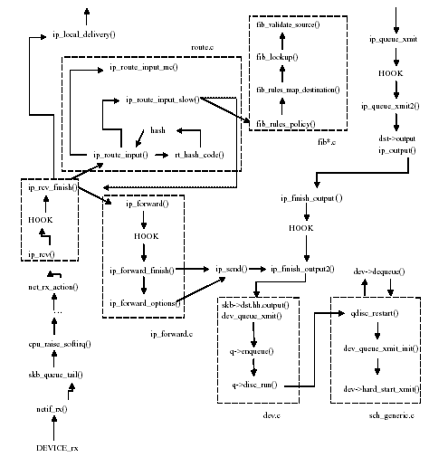
After hook functions have done whatever processing they need to do with a packet they must return one of the predefined Netfilter return codes.
These codes are:
Table 2: Netfilter return codes
Return Code Meaning
- NF_DROP Discard the packet.
- NF_ACCEPT Keep the packet.
- NF_STOLEN Forget about the packet.
- NF_QUEUE Queue packet for user space.
- NF_REPEAT Call this hook function again.
  - Decision of the Hook
When the packet reaches the host from the network, it goes through the network layer functions and when it reaches net_rx_action(), it is passed to ip_rcv()i.e. it reaches ip layer. After passing the first netfilter hook the packet reaches ip_rcv_finish(), which verifies whether the packet is for local delivery. If it is addressed to this host, the packet is given to ip_local_delivery(), which in turn will give it to the appropriate transport layer function. A packet can also reach the IP layer coming from the upper layers (e.g., delivered by TCP, or UDP, or coming directly to the IP layer from some applications).The first function to process the packet is then ip_queue_xmit(), which passes the packet to the output part through ip_output(). In the output part, the last changes to the packet are made in ip_finish_output() and the function dev_queue_transmit() is called; the latter enqueues the packet in the output queue. It also tries to run the network scheduler mechanism by calling qdisc_run(). This pointer will point to different functions, depending on the scheduler installed. A FIFO scheduler is installed by default, but this can be changed with the tc utility, as we have seen already. The scheduling functions (qdisc_restart() and dev_queue_xmit_init()) are independent of the rest of the IP code. When the output queue is full, q->enqueue returns an error which is propagated upward on the IP stack. This error is further propagated to the transport layer (TCP or UDP). If an incoming packet has a destination IP address other than that of the host, the latter acts as a router (a frequent scenario in small networks). If the host is configured to execute forwarding (this can be seen and set via /proc/sys/net/ipv4/ip_forward), it then has to be processed by a set of complex but very efficient functions. If the ip_forward variable is set to zero, it is not forwarded.
The route is calculated by calling ip_route_input(), which (if a fast hash does not exist) calls ip_route_input_slow(). The ip_route_input_slow() function calls the FIB (Forward Information Base) set of functions in the fib*.c files. The FIB structure is quite complex. If the packet is a multicast packet, the function that calculates the set of devices to transmit the packet to is ip_route_input_mc(). In this case, the IP destination is unchanged. After the route is calculated, ip_rcv_finished() inserts the new IP destination in the IP packet and the output device in the sk_buff structure. The packet is then passed to the forwarding functions (ip_forward() and ip_forward_finish()) which send it to the output components.

  - Algorithm of my project
In the router my program checks all the incoming packets and by reading the contents it gets information about the source ip, destination ip, source port and destination port if it is a TCP/IP packet. Using this information we determine as to which flow this packet belongs to. For the first packet of each flow that the router encounters my program creates a new node (data structure) and appends it to an existing link list. This link list is a collection of information of all the flows. Then my program checks if this flow already exists in the link list, if it does then no new node is created.
Then by doing pointer arithmetic the program reads the TCP data and also simultaneously searches the string. If the string is found then the found flag is set to 1 and also the count is incremented by 1. Subsequently the program extracts other information which is required to maintain the flows, like status of finish flag in the packet. Finally it checks if count > limit. If count > limit and found is set to 1 then the drop flag is set to 1 else drop flag is set to 0. Finally if the drop flag is 1 the packet is dropped using nf_drop function else the packet is let through using nf_accept function.
- Implementation
  - Code
3.1.1 Initialization & Cleanup
3.1.2 Makefile
3.1.3 Module
  - Explanation of Code
- Tests and Results
- Inferences
- Bibliography
Decision of the hook
sk_buff
Accessing TCP Data at ip layer using Pointer
Pointer type casting
Program Logic
Initialization and Cleanup

Makefile

Functions

- check if it is TCP/IP packet.
- get flow info and packet info.
- process_found(); -> create_if();
- process();
- finish();
- insert();
- process_drop();

Pointer Arithmatic

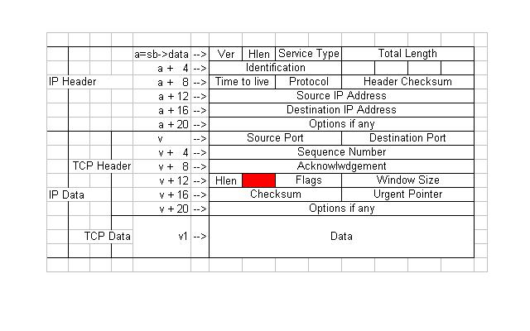
Applications of Project
- This software can be used as a limiting firewall for institutions like universities and companies.
- It can be used as a lightweight simulator.
- Using this simulator we can study the behavior of TCP for different types of drop patterns.
- This project uses link list where memory is dynamically allocated and deallocated, hence its use is time independent. So this project can be used to develop time independent software for the kernel.
- This project can be used for studying as to how exactly a flow is created, maintained and finished; we can also see as to which format is the data actually sent.
Further Expansions
- To be able to search a pattern or regular expression rather than a strict string. Eg.xx.xx.xx.xx
- To allow different keywords for different flows.
- Implementing functionality to allow user input of the search keyword.
- To use KVM Algorithm or Suffix trees to preprocess the string in order to improve the search time.

